**OOP WS31 ATTENDANCE TO CLASS**

**DATE: 02th february 2022**

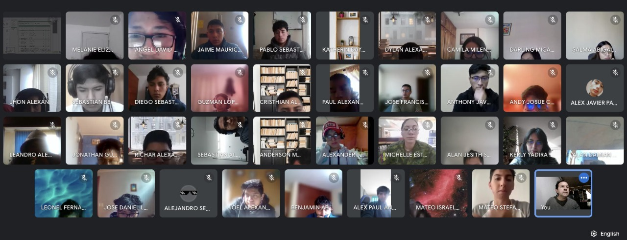

**Complete picture (Show all the face) → 10**

**Incomplete picture (Do not show all the face) → 9**

**Camera off → 7**

1 ALMACHE LITARDO ANDERSON MOISES 9

2 ALTAMIRANO BENALCAZAR CRISTHIAN ALEXANDER 9

3 ALVAREZ RAMIREZ MICHELLE ESTEFANIA 10

4 ANDRADE CARATE ALAN DAMIAN 9

5 ANDRANGO ESPINOSA ALEX PAUL 10

6 ARROBA SOLORZANO CRISTIAN ALEXANDER X

7 ASUMAZA GUALOTO DYLAN ALEXANDER 9

8 BRAVO RODRIGUEZ KATHERIN DAYANNE 9

9 BRAVO VILLALOBOS CHRISTIAN DAVID X

10 BUSTILLOS MONTENEGRO PABLO SEBASTIAN 10

11 CADENA ROMAN BENJAMIN ABEL 10

12 CAISATOA RAMIREZ SEBASTIAN BERNARDO 10

13 CALDERON MERCHAN ANDY JOSUE 10

14 CORREA RUIZ KERLY YADIRA 10

15 CRUZ PANTOJA DARLING MICAELA 9

16 DE LA CRUZ QUINGA ALEJANDRO SEBASTIAN 7

17 EIVAR DAGUA JAIME MAURICIO 10

18 GARCIA BARRETO MAYERLY PRISSILLA X

19 GOMEZ DIAZ MELISSA MALAYCA 9

20 GUAMAN VEJARANO ANGEL DAVID 10

21 GUITARRA SANCHEZ JHON ALEXANDER 10

22 GUZMAN LOPEZ JOSE DAVID 10

23 INSUASTI LOPEZ JONATHAN ESTEBA X

24 LANDAZURI SEGOVIA MATEO ISRAEL 9

25 LINCANGO CRIOLLO JOSE DANIEL 10

26 MAISINCHO PAUCAR RICHAR ALEXANDER 10

27 MALDONADO BASTIDAS MATEO STEFANO 10

28 MANTUANO FERNANDEZ LEONEL FERNANDO 10

29 MORALES CAICEDO ANTHONY JAVIER 10

30 PALACIOS CANDO DIEGO SEBASTIAN 10

31 PAUCAR LEMA ALEX JAVIER 7

32 QUINGA GUAYASAMIN LEANDRO ALEXANDER 10

33 RUANO PONCE ALEXANDER JAVIER 10

34 SALTOS TACO PAUL ALEXANDER 10

35 SANCHEZ MISHQUERO JOSE FRANCISCO 10

36 SHUGULI REINOSO ALAN JESITH 9

37 SIMBAÑA SIMBAÑA JONATHAN GUSTAVO 10

38 TAPIA ALBAN ANDREA JULIANNA X

39 TAYO RUIZ SEBASTIAN ALEJANDRO 10

40 TECA TELLO CAMILA MILENA 10

41 TERAN FLORES MELANIE ELIZABETH 9

42 VILLEGAS ESTRELLA SALMA ABIGAIL 10

43 ZEAS CLAVIJO JOEL ALEXANDER 10